Chapter 19, Solution 46.

Find the transmission parameters for the circuit in Fig.19.101.
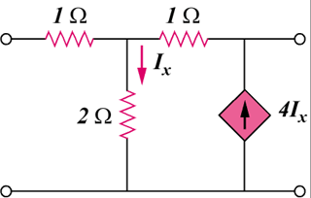

2 Ω

1 Ω

1 Ω

I_{x}

4I_{x}

Figure 19.101
For Prob. 19.46.

Solution

To get and , refer to the circuit in Fig.(a).

2

4 I_{x}

1

1
+

1

2

(a)

I_{x}

I₁

+

V₂

V₁

I₂ = 0

+

V_{o}

At node 1,
(1)

At node 2,
(2)

From (1) and (2),

But

To get and , consider the circuit in Fig. (b).

2

4 I_{x}

1

1
+

1

2

(b)

I_{x}

I₁

V₁

+

V_{o}

+

V₂ = 0

I₂

At node 1,
(3)

At node 2,
– (4)

Adding (3) and (4),
(5)

But (6)

Substituting (5) and (4) into (6),

Thus,

